AREA MAP

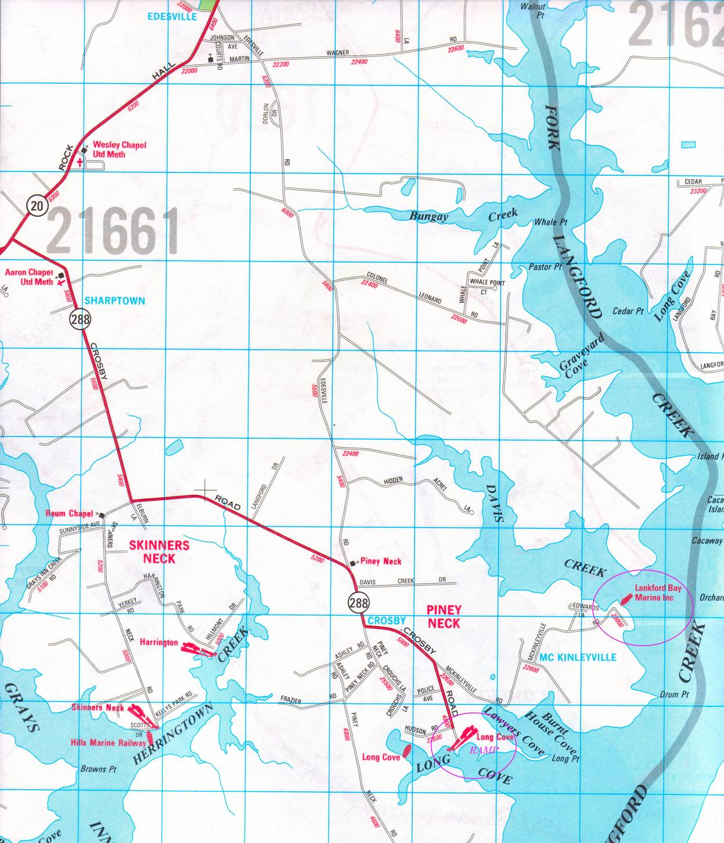

Directions to Long Cove boat ramp & Lankford Bay Marina – by land:

Rt. 213 into Chestertown to Rt. 291 (Morgnec Rd – 5th traffic light in Chestertown if coming north; 1st light past the Acme & Kent Plaza Shopping Center if coming south)

West on Rt. 291 for about ½ mile to Rt. 20.

Right on Rt. 20 – go approx. 12 miles on Rt. 20 to Rt. 288 (you’ll pass Edesville Rd. and Wesley Methodist Chapel on the left when you’re getting close).

Left on Rt. 288 (Crosby Rd.) – after about 1 mile, it takes a sharp left (if you stay straight, you’ll find yourself on Elburn Lane – turn around)

Follow Rt 288/Crosby Rd. past Langford Rd. (on left), Edesville Rd. (on left) and Davis Creek Rd. (on left).

Just after Davis Creek Rd., RT. 288/Crosby Rd. turns left – if you stay straight, you’ll end up on Crouch’s Lane – Terraplane Tom’s house is just down the road at 22519 Crouch’s Lane.

To get to the marina or the boat ramp, turn left, staying on Rt. 288/Crosby Rd. - in about ¼ mile the road will fork. To the right is the ramp,- to the left is the marina.

For the boat ramp, take the right fork - Crosby Road /Rt. 288 – go for another ¼ mile to Long Cove boat ramp.

To get to the marina, take the left fork on McKinleyville Rd. Follow it as it winds around to Lankford Bay Marina (see the map).

If you get lost, you can call the marina (410-778-1414), me (410-708-5094), or
Tom (443-480-6056).
